Input | Expected output | Actual output | Passed (?)
Any number | Accepts number, returns weight list | 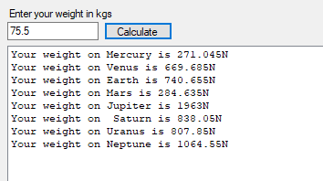 | ☒
No number | Enter a valid number! E.g. 27.4 message box. | 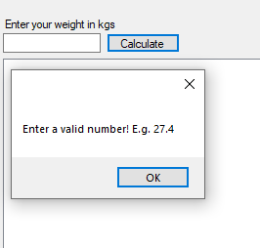 | ☒
String in textbox | Enter a valid number! E.g. 27.4 message box. | 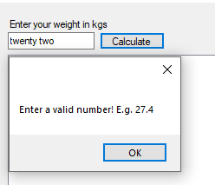 | ☒
Weight of 635 | Accepts number, returns weight list | 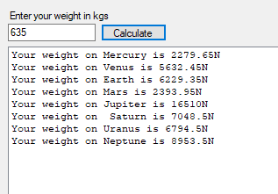 | ☒
Weight of 635.1 | Weight out of range, please enter a number between 0 and 635. | 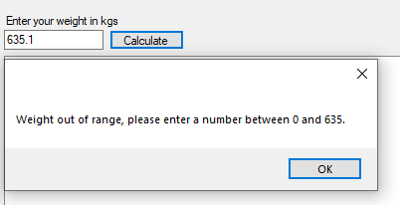 | ☒
Weight of 0 | Accepts number, returns weight list | 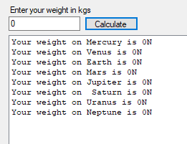 | ☒
Weight of -0.1 | Weight out of range, please enter a number between 0 and 635. |   
      

